**AWK**

**Know pre-defined and automatic variables in AWK**

AWK supports a couple of pre-defined and automatic *variables* to help you write your programs. Among them you will often encounter:

* **RS** –*The record separator.* AWK processes your data one record at a time. The record separator is the delimiter used to split the input data stream into records. By default, this is the newline character. So if you do not change it, a record is one line of the input file.
* **NR** – *The current input record number.* If you are using the standard newline delimiter for your records, this match with the current input line number.
* **FS/OFS** –*The character(s) used as the field separator.* Once AWK reads a record, it splits it into different fields based on the value of **FS**. When AWK print a record on the output, it will rejoin the fields, but this time, using the **OFS** separator instead of the **FS** separator. Usually, **FS** and **OFS** are the same, but this is not mandatory. “white space” is the default value for both of them.
* **NF** – The number of fields in the current record. If you are using the standard “white space” delimiter for your fields, this will match with the number of words in the current record.

**Basic usage of AWK command**

**1. Print all lines**

This example is mostly useless, but it will nevertheless be a good introduction the AWK syntax.

**awk '1 { print }' file**

AWK programs are made of one or many **pattern {action}**  statements.

If, for a given *record* (“line”) of the input file, the *pattern* evaluates to a non-zero value (equivalent to “true” in AWK), the commands in the corresponding *action block* are executed. In the above example, since **1** is a non-zero constant, the **{ print }** action block is executed for each input record.

Another trick is **{ print }** is the default action block that will be used by [AWK if](https://linuxhandbook.com/awk-if-else/) you do not explicitly specify one. So the above command can be shortened as:

**awk 1 file**

Almost as useless, the following AWK program will consume its input but will not produce anything to the output.

**4. Removing whitespace-only line**

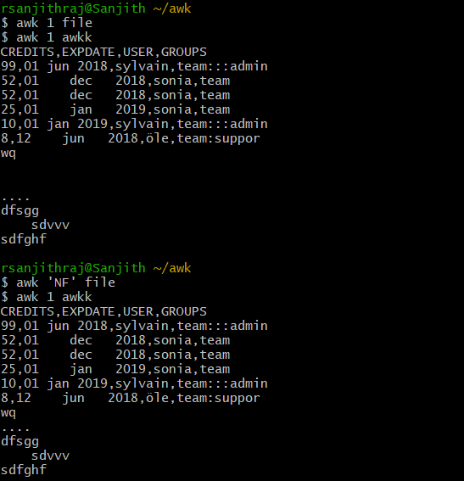

Field Separators

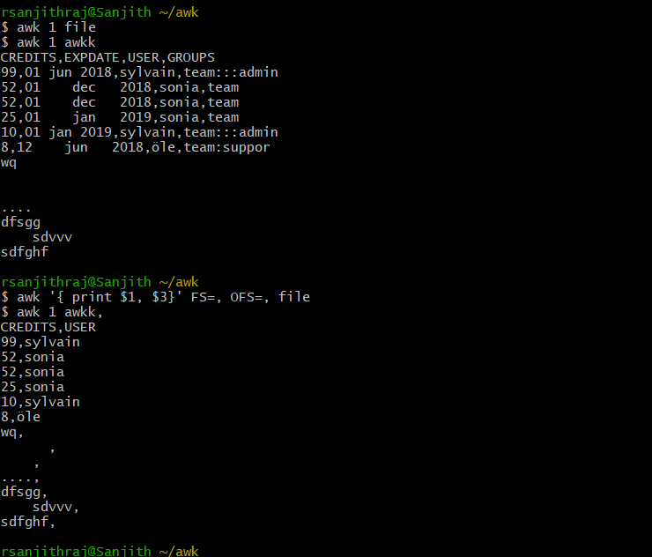

Performing the calculation collum wise

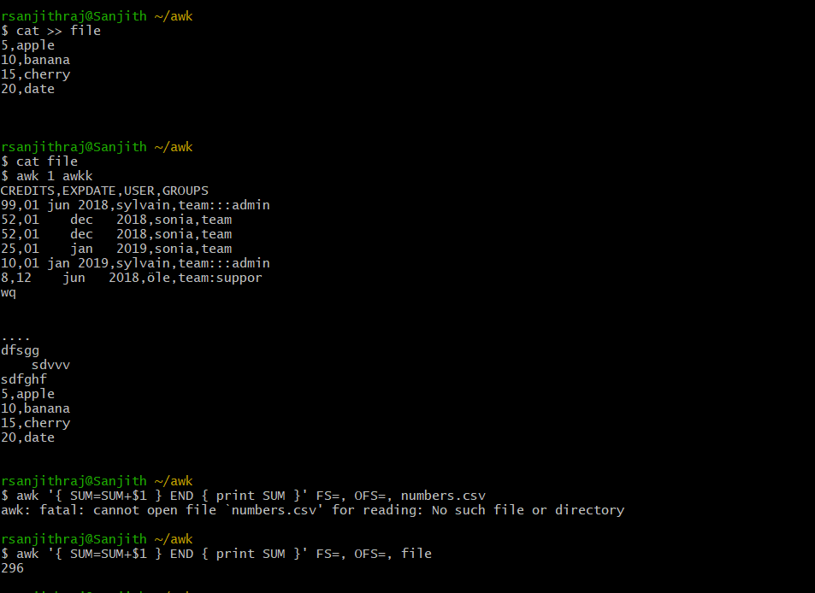

To count nonempty lines

